Experiment No 1.2

**Create a “HELLO WORLD” application.**

**AIM:** To design an android application to display Hello World

First step is to create a simple Android Application using Android studio. When you click on Android studio icon, it will show screen as shown below

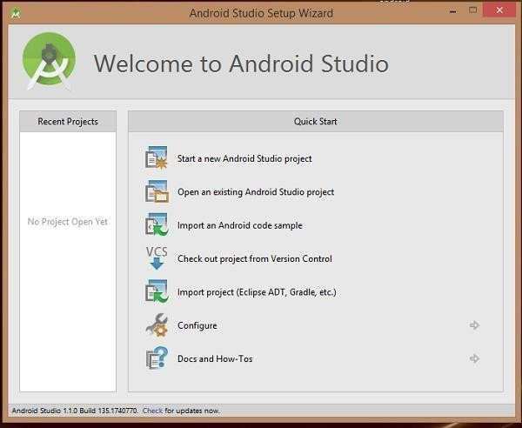

You can start your application development by calling start a new android studio project. in a new installation frame should ask Application name, package information and location of the project.−

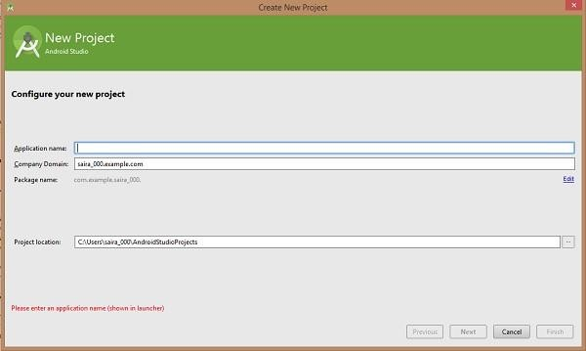

Configure the Hello World Project Details We'll finish creating the project by configuring some details about its name, location, and the API version it

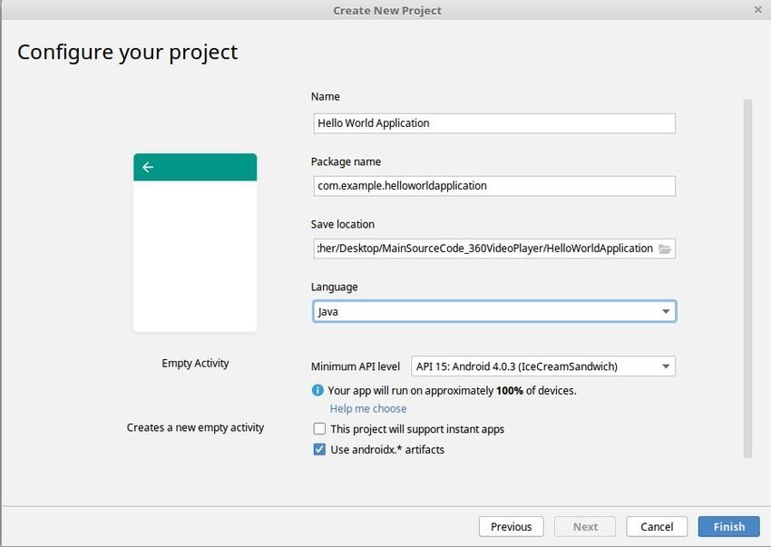

Change the name of the application. Change the default **Project location** to your preferred directory or just leave it as the default location.

On the **minimum API level**, ensure that **API 15: Android 4.0.3 IceCreamSandwich** is set as the Minimum SDK. This ensures that your application runs on almost all devices.

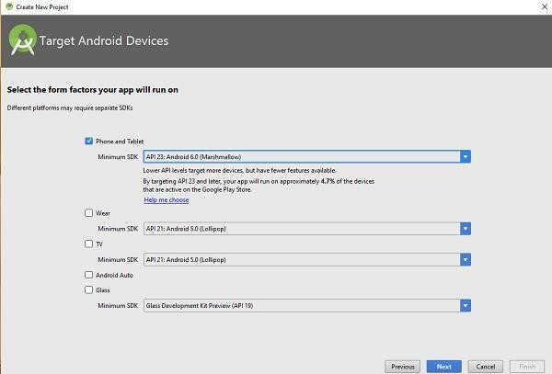

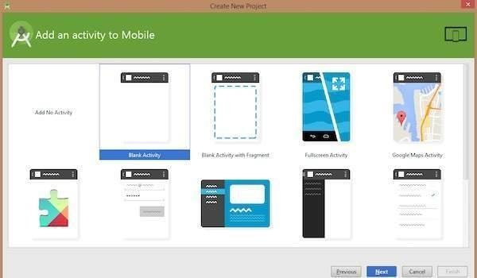The next level of installation should contain selecting the activity to mobile, it specifies the default layout for Applications.

**SOURCE CODE :**

**The Main Activity File**

## The main activity code is a Java file MainActivity.java. This is the actual application file which ultimately gets converted to a Dalvik executable and runs your application

package com.example.helloworldapplication;

import androidx.appcompat.app.AppCompatActivity; import android.os.Bundle;

public class MainActivity extends AppCompatActivity {

@Override

protected void onCreate(Bundle savedInstanceState) { super.onCreate(savedInstanceState); setContentView(R.layout.activity_main);

}

}

## The Layout File

The **activity_main.xml** is a layout file available in res/layout directory, that is referenced by your application when building its interface. You will modify this file very frequently to change the layout of your application. For your "Hello World!" application, this file will have following content related to default layout −

<RelativeLayout xmlns:android[="h](http://schemas.android.com/apk/res/android)tt[p://schemas.android.com/apk/res/android](http://schemas.android.com/apk/res/android)" xmlns:tools[="h](http://schemas.android.com/tools)tt[p://schemas.android.com/tools](http://schemas.android.com/tools)" android:layout_width="match_parent" android:layout_height="match_parent" >

<TextView android:layout_width="wrap_content" android:layout_height="wrap_content" android:layout_centerHorizontal="true" android:layout_centerVertical="true" android:padding="@dimen/padding_medium" android:text="@string/hello_world" tools:context=".MainActivity" />

### I )Running app on Phone:

***Connect your Phone to Computer***

### Plug in your device to your computer with a USB cable. If you're developing on Windows, you might need to install this [universal ADB USB driver](http://download.clockworkmod.com/test/UniversalAdbDriverSetup.msi) or find your [specific USB driver for your device](https://developer.android.com/tools/extras/oem-usb.html).

***Enable USB Debugging***

The next step is to enable USB debugging so your phone can interact with your computer in a developer mode.

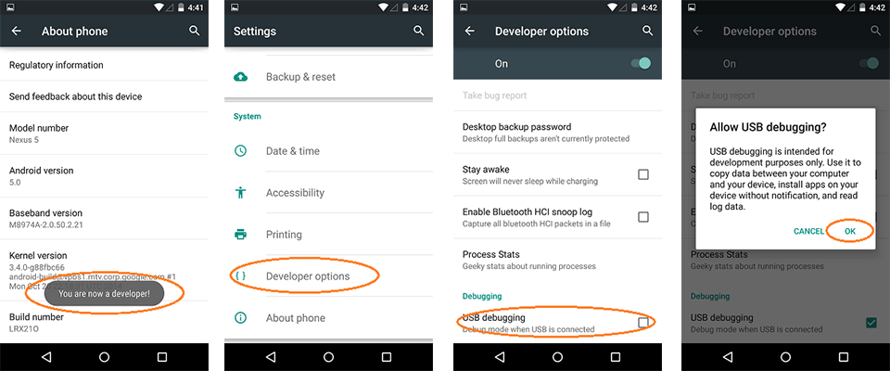

The following steps are needed:

1. (Windows Only) Install [this ADB Driver](http://download.clockworkmod.com/test/UniversalAdbDriverSetup.msi)
2. Plug-in your Android Device to Computer via USB
3. Open the "Settings" App on the Device
4. Scroll down to bottom to find "About phone" item
5. Scroll down to bottom to find "Build number" section
6. Tap on "Build Number" 7 times in quick succession
7. You should see the message "You are now a developer!"
8. Go back to main "Settings" page
9. Scroll down bottom to find "Developer options" item
10. Turn on "USB Debugging" switch and hit "OK"
11. Unplug and re-plug the device
12. Dialog appears "Allow USB Debugging?"
13. Check "Always allow from this computer" and then hit "OK"

### Running your App

Now, we can launch apps from Android Studio onto our device:

1. Select one of your projects and click "Run" from the toolbar.
2. In the "Choose Device" window that appears, select the "Choose a running device" radio button, select the device, and click OK.

II) Running app on Emulator(AVD)

To run the app from Android studio, open one of your project's activity files and click Run Eclipse Run Icon icon from the tool bar. Android studio installs the app on your AVD and starts it and if everything is fine with your set-up and application, it will display following Emulator window −Once Gradle finishes building, Android Studio should install the app on your connected device and start it.

